1. Business Process Scope 2
2. Process approach in ERP 2
2.1 Modeling of business requirements in ERP 2
2.1.1. To-Be process flow description 2
2.1.2. To-Be process flow chart 4
3. Gap Analysis 5
4. Business Process Approval 5

Business Process Scope

RM/PM Procurement Process

Process approach in ERP

Modeling of business requirements in ERP

To-Be process flow description

Sr.  No. | As-Is Business Process & Expectation | To-Be Processes Mapping in ERP | System & Role | Change
1 | Material Request is Manual Process. | Material Request to be create by ERPNext now by Branch wise  • Process flow  Stock > Material Request  Document Type :- Material Request  Number Range :- MR/{Branch Code}/FY/##### | ERP Next Process  [Any Branch user can be create Material Request ] | High,  Reason:- Currently its a manual process.
2 | Material Request Approval by Manual | Material Request approval by Branch/Department head  ** Approval can be at multi label.  Notification on through Email /Bell Icon. | ERP Next Process  Approved by Authorized person | High,  Reason:- Currently its Reason:- Currently its a manual process.
3 | Request for quotation from supplier by manual process. | Request for quotation perform by ERPNext.  Process Flow:-  Home > Buying > Purchasing > Request for Quotation  Document Type :- Request for Quotation  Number Range :- RFQ/{Branch Code}/FY/#####  *Automatic Email trigger to Suppliers for Quotation Submission | ERP Next Process  Purchase User/Manager | Medium,  Reason:- Currently its a manual process but it’s a optional process.
4 | Quotation received from Supplier entered Manually in Easy ERP. | It’s a auto entry process by ERPNext. If the supplier fills quotation on your request then, it will be auto receive on ERPNext.  Process Flow:- Buying > Purchasing > Supplier Quotation > New.  Document Type :- Supplier Quotation  Number Range :- PUR-SQ-{FY}-#####  A Supplier Quotation is document by a potential supplier specifying the cost of goods or services they'll provide within a specified period. | ERP Next Process  User :-Supplier | Low,  Reason :- because its auto entry
5 | Quotation comparison by purchase head. | “Quoted Item Comparison” report will be available for comparison.  Process Flow :- Buying > Supplier Quotation >Report | ERP Next Process  User :-Purchase Team | High,  Reason :- because its auto entry
6 | Quotation Approval by Authorized Person | Approval by Authorized Person  * Notification on through Email /Bell Icon. | ERP Next Process  User :-Purchase Head | Low,  Reason :- Doing Same thing
7 | PO creation based on approved quotation | Purchase Order Creation by Purchase Department at Head Office.  Process Flow:- Home > Buying > Purchasing > Purchase Order  Document Type :- Purchase Order  Number Range :- PO-{Branch Code}-{FY}-#####  *Template Needs to be created | ERP Next Process  User :-Purchase User | Low,  Reason :- Doing Same thing
8 | PO Approved by Authorized Person | Approval by Authorized Person | ERP Next Process  User :-Purchase Head | Low,  Reason :- Doing Same thing
9 | Inward Challan Created at the time of Material Receiving at gate point by store user. | - Inward challan create only for without PO materials.  - We proposed Inward Challan Entry in Purchase Receipt (MRN) Only for PO related materials. | N/A in ERPNext  (New Module ) | Low,  Reason:- Doing same thing in Easy ERP
10 | Inward Challan also approved by authorized person. | Approval done during the Purchased Receipt & Inward challan by authorized person. | N/A in ERPNext  (New Module ) | Low,  Reason:- Doing same thing in Easy ERP
11 | MRN created by store user but stock is not reflected till QC | MRN created by store person with Inward Challan details, but till the QC process will be in Draft Mode.  Process Flow :  Home > Stock > Stock Transactions > Purchase Receipt  Document Type : Purchase Receipt  Number Range :- PR-{Branch Code}-{FY}-##### | ERP Next Process  User :-Store User | Medium,  Reason :- Doing Same thing in MRN but add gate entry data
12 | Quality Check | Quality Check by QC team/user on given parameters.  Process Flow :- Home > Stock > Tools > Quality Inspection  Document Type:- Quality Inspection  Number Range :- QI-{Branch Code}-{FY}-##### | ERP Next Process  User :-QC | Low,  Reason :- Doing Same thing
13 | Once QC passed then stock will moved to respective WH | Approval by Authorized Person | ERP Next Process  User :-QC Head | Low,  Reason :- Doing Same thing
14 | Stock Effected by QC approval | After Purchase received approval stock updated on respective  Ware house.  Process Flow: Home > Stock > Stock Transactions > Purchase Receipt  Document Type:- Purchase Receipt | ERP Next Process  User :-Store Incharge | Low,  Reason :- Doing Same thing

To-Be process flow chart
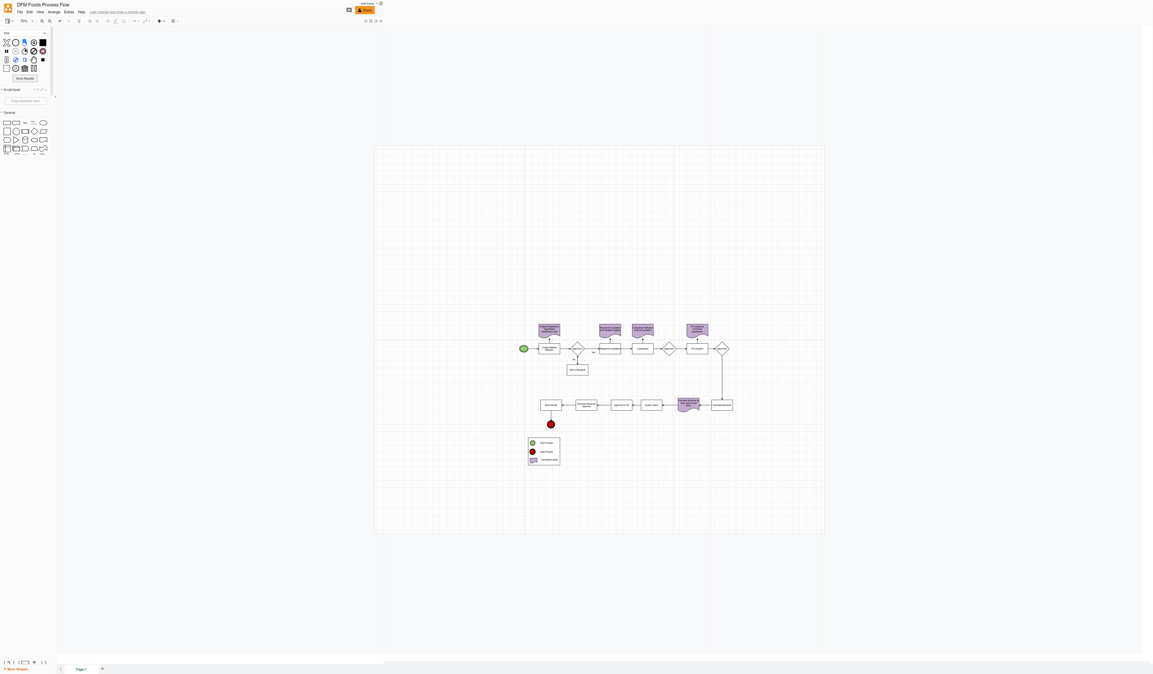

Gap Analysis

Sr. No. | Gap Description | Approach**
1 | Material Request process is not followed in Easy ERP | Material Request to be generated by authorized user
2 | Currently Purchase Order is created department wise | Purchase Order created by Purchase department based on the Material Request.
3 | Quotation by Supplier is manual process | It can be done by the System.
4 | Currently, Inward challan (Gate Entry) performed by store user | Now, this process is involve in MRN for PO material and without PO material will be in Inward challan.

**Identify that there is a needed business function that cannot be accommodated by ERP. Mention System modification that needs to be done- at a higher level, any future enhancements which might address the requirement

Business Process Approval

DFM Foods |  |  | Implementation Partner
Name | Project Role | Signature | Name | Project Role | Signature
 |  |  | Venkatesh Nayak | Project Expert
 |  |  | Prashant Verma | Project Manager

